Ella Belcher
Language Editor and Translator
22 Bruton Place
Heldervue
Somerset West

Member of the South African Translators’ Institute
Member of the Professional Editors’ Group
 +27+21-8870572  083 294 8393
Postal address: P.O. Box 12570 Die Boord 7613 South Africa

DECLARATION

I hereby certify that the article mentioned below has been properly language edited.

Title of article

An adapted measure of ethical climate in organisations – a South African study

Author
Prof A Grobler PhD (Industrial and Organisational Psychology)
Area Head: Leadership and Organisational Behaviour
Graduate School for Business Leadership

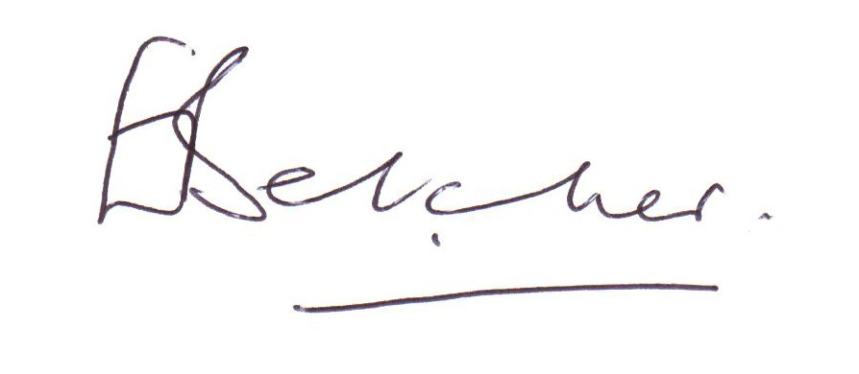

ELLA BELCHER
Somerset West
15 November 2015

